AMERICAN CAR CRAFT
18701 Old Shady Hill Rd. Spring Hill, Fl. 34610
Phone: 727 857-1151 Fax: 727 856-0273
www.americancarcraft.com

C6 CORVETTE COMPONENT WATER TANK COVER
PART# C634 patent pending

INSTALLATION INSTRUCTIONS

PARTS INCLUDED:
___1-Stainless Water Tank Cover
___1-Decorative Hose Collar
___1-Adhesive Promoter
___2-Decorative Chrome Caps w/Velcro Cookies

Your new accessory comes to you with a clear protective liner. This liner will help to keep your new parts clean during installation. You will be instructed when to remove the liner during the detailed installation.

YOUR NEW COVER HAS BEEN DESIGNED TO DRAMATICALLY ENHANCE THE LOOK OF THE FACTORY OVERFLOW TANK AND WILL ADD A REALLY NICE CUSTOM LOOK TO YOUR ENGINE BAY.

- Using a pair of vice grips clamp the top flow hose so that when you remove it, it will not leak any fluid. Using a regular plier’s squeeze the hose clamp to remove the hose. Hold the hose straight up and lower the vise grip down some. Use a paper towel to soak out the fluid in the hose. Remove the hose clamp.

- Slide the decorative hose collar over the hose so that the large opening of the collar faces towards the tank. Slide it down the tube enough to allow you to re-install the hose clamp.

- Remove the factory water tank cap and the windshield washer fluid cap. You will notice that the water tank has a plastic overflow tube set into a hole retainer attached to the tank. Pull this tube out of this retainer and allow it to lie next to it outside of the hole.

- Installing the new cover is quite simple. Slide the cover over the top flow tube then slightly buckle the cover past the water fill neck hole to allow the cover to insert under the hood gasket ridge as you jostle the cover over the water fill neck and windshield washer fluid cap neck.

- Your factory windshield washer fluid cap is attached to the neck with a plastic strap. This strap will need to be trimmed off at the caps base using a common scissor. You will also need to trim the finger tab from this cap in the same way. Once this is done simply snap the cap onto the fill neck.

- Replace the factory water tank cap and scrub the tops of both factory caps with household rubbing alcohol to remove any dirt and grime then swipe the two caps with the adhesive promoter provided.

- You have been provided with two decorative chrome caps. You will notice that these caps will contain Velcro attachment cookies inside them. Remove the cookies halves and install them on top of the two factory fluid caps you just prepared.

- At this time remove the clear protective liner.

- Install the two corresponding caps and the top water hose. Be sure that the factory hose clamp ears face downward as best as possible. Then slide the notched chrome hose cover over the clamp to finish the installation.

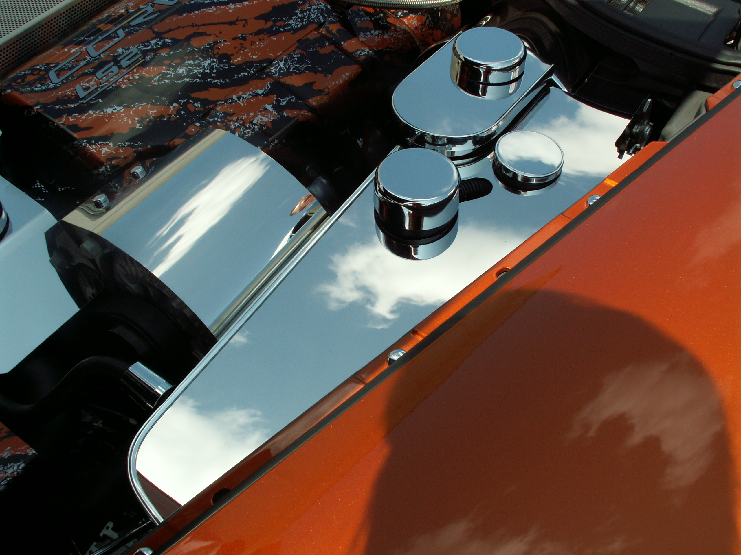

If any questions occur during installation, please contact American Car Craft at 727 857-1151. Thank you and enjoy your new cover.
Note: Care must be taken when cleaning your cover. It is a good idea to lightly dust your cover with a clean soft cloth first in order to prevent any particles from scratching it. Then wipe (using a new clean soft cloth) with a good quality streak free glass cleaner. SEE ENCLOSED CARE SHEET!

